Communication Board
Student’s Name
Institutional Affiliation
Date

Communication Board
A communication board is defined as a tool that contains illustrations, symbols, and photos that help individuals with challenges associated with their language and communication skills. This tool allows these individuals to either point or gesture to one of the objects displayed on the board to communicate with others (Ganz & Simpson, 2019). Besides, there are various types of communication boards, including an augmentative communication board, which is based on the use of an electronic device. In this case, the individual considered has ASD; therefore, they require the communication board to develop their communication skills. The development of a communication board may apply to various areas, including the class subjects (Boutot, 2017). The developed communication board would be designed to match the student; for example, if the student uses single words, then I would include single words and a few double words to improve his understanding.
Language Arts/Reading
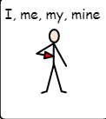 | 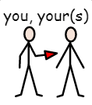 | 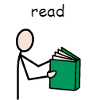 | 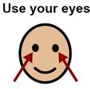
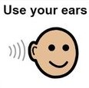 | 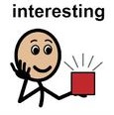 | 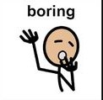 | 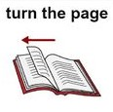
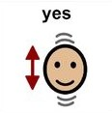 | 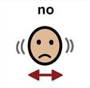 |  | 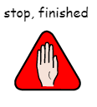

For an augmentative communication board focused on the student’s reading, I would include several things related to the basics of reading. I would consist of independent clauses and verbs to help with the interpretation, making it easy for the student. In reading, these essential parts of a simple sentence would help the student communicate and also learn how to read.
Math
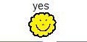 | 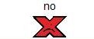 |  | 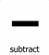
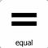 | 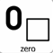 | 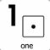 | 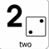
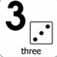 | 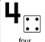 | 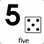 | 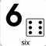
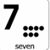 | 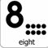 | 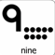 | 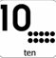
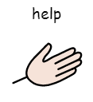 | 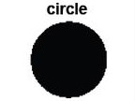 | 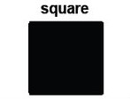 | 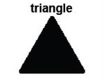
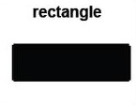 | 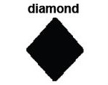 | 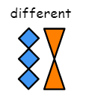 | 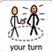

Since one of the challenges that students with ASD have is intellectual disability, I would include a math board with functions broken down to smaller parts for easier understanding. Therefore, having a board with the numbers and pictorial items to help understand the amount is helpful. The board would help the student communicate and clearly understand the concepts he is communicating.
Science
Weather and Seasons
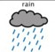 | 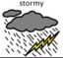 | 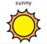 | 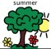
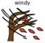 | 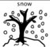 | 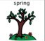 | 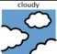
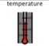 | 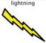 | 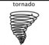 | 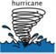

The science communication board includes some of the basic science concepts such as the weather which forms part of the environment. I would include the fundamental aspects of the seasons that influence the weather, which are essential for the student to use to communicate. Moreover, the board's images also aid in understanding these aspects by the student, such as during winter there is snow and a hurricane involves wind blowing.
Social Studies
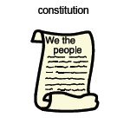 | 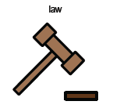 | 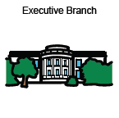 | 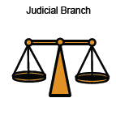
 | 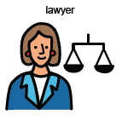 | 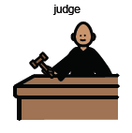 | 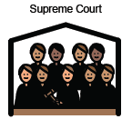
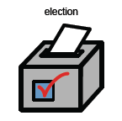 | 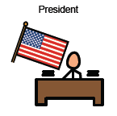 | 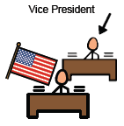 | 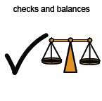

Social studies entail a variety of concepts in society, such as legislation and politics. Therefore, using the board with pictorial items indicating the symbols and the meaning of those symbols picture showing that it is a document that contains content for the people.
Emotional/Behavioral Skills
 | 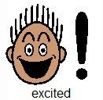 | 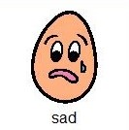 | 
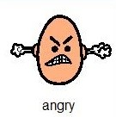 | 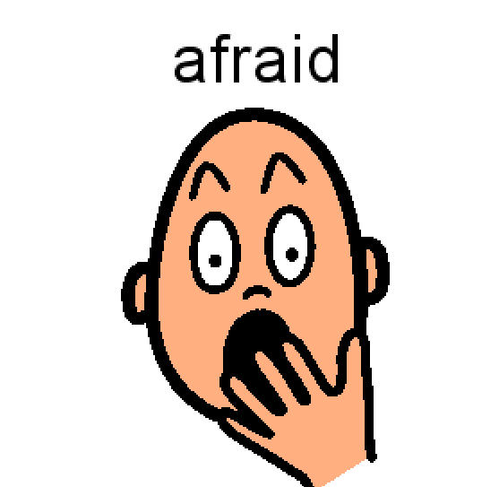 | 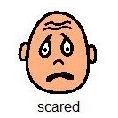 | 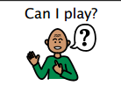
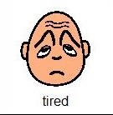 | 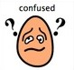 | 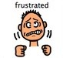 | 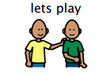

For a student with ASD, it may be a challenge to express their emotions; therefore, I would use the board above, which has various emotions. Thus, if the student involved felt some emotion, they would point at the images used to communicate. At the same time, they would understand some concepts such as heat from the sun could lead to one feeling hot.
Art/Music/P.E.
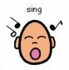 | 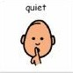 | 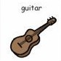 | 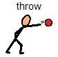 | 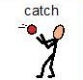
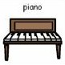 | 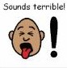 | 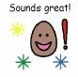 | 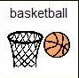 | 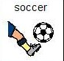
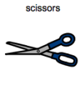 | 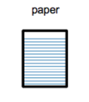 | 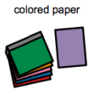 | 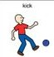 | 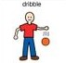
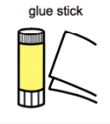 | 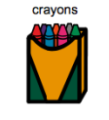 | 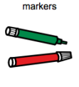 | 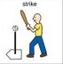 | 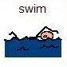

The board, in this case, would be made up of all activities involved in art class, music class, and P.E. I would implement a board with various activities such as music instruments, running, and colors. This board would help the student communicate their favorite activities and, at the same time, express their feelings during the same. This board would also help the student follow up with the activities involved by indicating the scores, playing the instruments, and partaking in the painting process.
Cafeteria
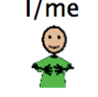 | 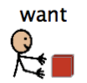 | 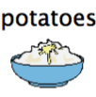 | 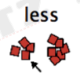
 |  | 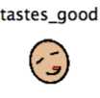 | 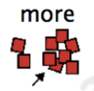
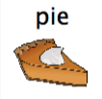 | 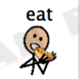 | 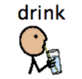 | 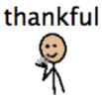

Lastly, regarding the cafeteria communication board, I would use symbols that help students communicate their preferences by expressing emotions such as ‘tastes good’ and ‘like.’ Moreover, the board would also help the student express themselves by pointing out what they want and when they need help. The pictures used in the communication board would also help the student know what they ask for.
References
Boutot, A. E. (2017). Autism Spectrum Disorders. Boston: Pearson
Ganz, J. B., & Simpson, R. L. (2019). Interventions for Individuals with Autism Spectrum Disorder and Complex Communication Needs. Augmentative and Alternative Communication Series. Brookes Publishing Company.

